Operating Systems
Student Name: Ahmad Marwan Maghaireh
ID : 23110205

Table of Contents
Contents
Task 1 – Operating Systems Definitions and Services 1
Task 2 – Evolutionary Milestones in the Developmnt of Windows 3
Task 3 – Memory Management (Page Replacement Algorithms) 5
A. LRU replacement 5
Task 4 – Process Scheduling 9
Task 5 – Linux File and Directory Commands 11
Task 6 – Windows Commands 17
Task 7 – Artificial Intelligence in Operating Systems 22
Task 8 – Secure Collaborative Environment for CityTechnologies Project 24
Task 9 – Virtualizaton and Containerizaton 33
Task 10 – Cybersecurity, Privacy, and Modern Operating Systems 34

Task 1 – Operating Systems Definitions and Services
A. Should operating systems include bundled applicatons such as web browsers and email clients
Supporting Argument:
Including bundled applications such as web browsers and email clients with the operatng system provides several advantages
• User Convenince: New users can immediatly perform essential tasks such as browsing the internet or sending emails without having search for and install third party applications. This particulary beneficial for novice users or organizatons that require basic functionality out of the box
• Seamless Integraton: Bundled applications are often tightly integrated with the operating systm ensuring consistent performnce and compatibility. For example integrated browsers can leverage OS level security features and default email clients may syncronize seamlessly with the systems notification services
• Enhanced Securty: When applications are developd and maintained by the OS vendor security patches and updates are deliverd through the same update mechanism as the operatng system. This reduces risk of vulnerabilties and simplify the process of maintainng a secure computing environment
Opposing Argument:
On the other hand there are strong arguments aganst bundling applications with operating systems
• Bloat and Resorce Usage: Pre installed applications can increse the size of the operatng system consume unnecessary storag and sometimes run background proceses that slow system performance
• Reduced Flexibillty: Bundling restricts user choice as users may prefer alternatve software that better suits there needs. Pre installed software may discourge exploration of independnt applications limiting customizatn
• Antitrust and Fair Competiton Issues: Bundling can lead to monopolstic practices where the operating systm vendor gains unfair advantage over indepenent developers. Historical cases such as Microsoft bundling Internet Explorer with Windows illustrate how such practces can trigger legal and regulatry concerns
While bundling applcatons enhances convenience integration and security it raises valid concerns about bloat reduced user freedom and fair competiton. A balance approach would be to provide minimal set of applicatons while allowng users to easily remove or replac them with alternatives
B. Four Critical Services Provided by an Operating System
- File Managment
o The operating system organizes stores and retrievs files on storag devices
o It provide users with a logical strcture (directories and file systems) and control access permissions
o This service enhances convenince by ensuring data can be saved and located effciently while also protectng files from unauthorizd access
- Process Schedulng
o The OS manages the executon of multiple proceses allocating CPU time through scheduling algoriths
o It ensure fairness responsiveness and efficent use of the processor
o This enhance system functionality by allowng multitasking enable users to run multiple applcatons simultaneously without noticeble delays
- Memory Managment
o The operating systm allocats and deallocats memory space for proceses ensuring optiml use of availble RAM
o It handle swapping paging and segmentaton to prevent memory conficts
o This service improv functionality by preventng crashs reducing fragmentatn and ensuring proceses have the resorces they require
- Device Managment
o The OS act as an intermediay between hardware devices such as printers keyboards and storag drives and applicatons
o It use device drivers to standardze communication and manage input output operations
o This service simplifes user interacton with hardware ensuring compatbilty and effcient use of conected devices

Task 2 – Evolutionary Milestones in the Developmnt of Windows
The Microsoft Windows operating systm has undergone significant evolutn since its early days as a graphical extension of MS DOS to its current role as platfrm for personal computng enterprise servers and cloud integration. This developmnt reflects changes in user needs technlogical advancements and market trends
A. GUI Innovatons: Windows 95 and the Start Menu
Windows 95 introducd the Start Menu a feature that fundamntally changed how users interactd with operating systms
• Centralizd Access The Start Menu consolidted programs settings and recently used files into a single interfac making navigatn intuitive. This design significntly reduced complexity of accessng applicatons compared to Program Manager in Windows 3x
• Taskbar Introducton Alongside the Start Menu the taskbar allowd users to manage multiple open windows simultaneusly facilitatng multitasking
• Legacy in Modern Windows Although its appearanc has evolvd the Start Menu remains central in modern Windows versions includng Windows 10 and 11. It continus to provide quick access to frequently used applicatons but now incorporat search functnality live tiles Windows 10 and cloud integratn with Microsoft services demonstratng adaptability while retainng its origial purpose
B. Internet and Cloud Integratn
The internet era reshaped operating systms and Windows adaptd through both software and service integratn
• Internet Explorer IE Bundled with Windows 95 Plus Pack and later versins IE allowd users to access web natively. Although controversal for its role in antitrust cases it set the stage for widespred internet adoptin among PC users
• Microsoft Edge Replacng IE in Windows 10 Edge providd improv performance securty and standards complance. Edge integratn with features such as Cortana Microsoft 365 and cross device synchronizaton illustrate Microsoft focus on web and cloud ecosystms
• Cloud Servics Windows increasngly integrat with OneDrive for file syncronizatn and storag and enterprse tools like Azure Active Directory for identty and access managemnt. These services extend Windows role beyond local machine turnng it into gateway for hybrid cloud computng enviroments
C. Security Enhancemnts
Securty has becme critical focus in Windows evolutn especialy as cyber threats grown more sophisticatd
• User Account Control UAC Introducd in Windows Vista UAC requird users to approv administratve actions reducing the liklihood of unautorizd system changes. Although initialy critcized for being intrusiv UAC markd major step toward principle of least privilege computng
• Windows Defender Originaly anti spyware tool Windows Defender maturd into full antivirus and endpont protectn systm. In Windows 10 and later it becme default integratd defense platform with real time scaning firewall features and ransomwar protectn
• Trusted Platform Module TPM TPM chips provid hardware based securty for encrytion and authenticatn. With Windows 11 mandating TPM 20 Microsoft emphasiz secure boot BitLocker encryptn and enhancd identty protectn seting new standard for baseline securty
D. Touch and Hybrid Computng
The rise of smartphones and tabletts influencd Microsoft attempt to reposition Windows as touch frendly OS
• Windows 8 2012 Introducd a touch centric Metro interfac with full screen tiles. While inovative this design alienatd desktop users who relid on traditonal keyboard and mouse input. The removal of Start Menu was widly critcized and adoptn rates sufferd
• Windows 10 2015 Correctd these issues by restorng Start Menu while stil supportng touch gesturs and tablet mode. The Continuum feature allowd seamless switchng between touch and desktop modes ensur usability across laptops tablets and hybrid devics. This balance helpd re establish Windows as versatil platform for diferent hardware catgories
E. Windows as a Service Model
With Windows 10 Microsoft abandon traditional model of major versin releass in favor of Windows as a Service
• Advantages
o Continuous Updates Securty vulnerabilties patchd more quickly reducing exposur to threats
o Feature Evolutn Users gain acces to incremental improvments without waitng for new versin releas
o Unified Platfrm Maintains consistncy across consumer and enterprse enviroments reducing fragmentatn
• Disadvantages
o Forced Updates Some users and organizatons exprssed frustratn with limited control over update timing occasionaly leadng to disrptons
o Compatibillty Issues Frequent updates sometims caused conficts with hardware drivers or enterprse applicatons
o Resource Demands Continuous updatng requirs reliable internet connectvity and storag space which may be chalenging for some users
The Windows operatng systm has evolvd through pivotal milestons the Start Menu as revolutonary interfac deep integratn with internet and cloud services progresive securty enhancemnts adaptatn to touch based devics and adoptin of service orientd model. Each stage reflect Microsoft attempt to balance user expectatons technlogical shifts and competitve pressurs resultng in Windows becomng not only desktop OS but also platform central to modern computng ecosystms

Task 3 – Memory Management (Page Replacement Algorithms)
Reference string:
1, 2, 3, 4, 2, 1, 5, 6, 2, 1, 2, 3, 7, 6, 3, 2, 1, 2, 3, 6

LRU (Least Recently Used): a cache replacement policy that removes the data block or page from memory that was accessed the longest time ago, based on the temporal locality principle.
FIFO (First-In-First-Out): It's a simple queuing method where the first item to enter a queue is the first to be processed or removed.

A) LRU Replacement (3 Frames)

The key is to replace the page that was least recently used.

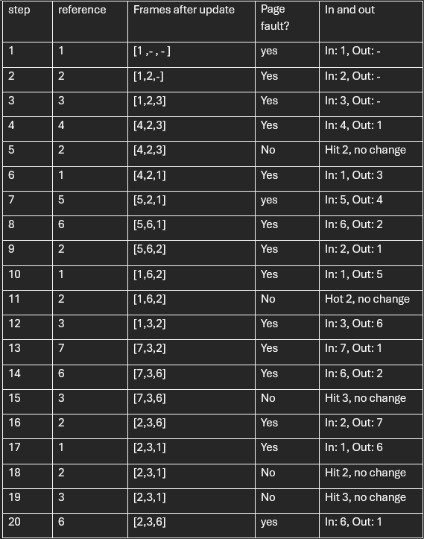

Total LRU page faults = 15.

B) FIFO replacement 3 frames.
The key is to replace the oldest loaded page when a new page must fit.

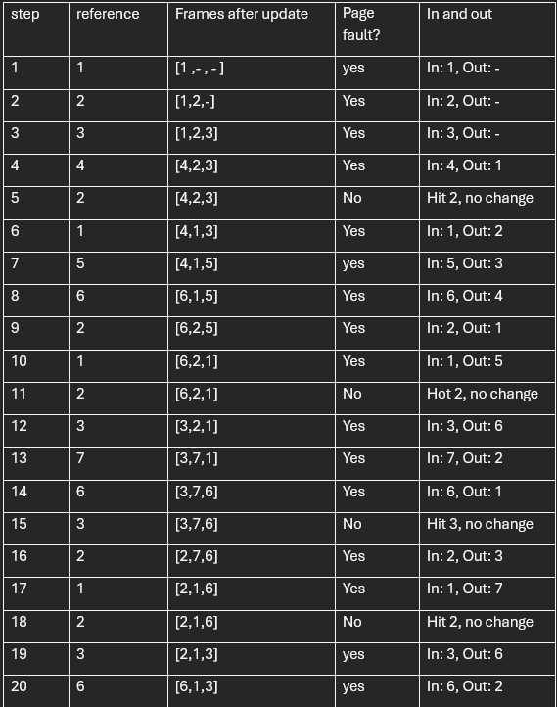

Total FIFO page faults = 16.

Task 4 – Process Scheduling
Given processes
Process | Arrival | Burst | Priority (1 = highest)
P1 | 0 | 8 | 3
P2 | 1 | 1 | 1
P3 | 2 | 3 | 4
P4 | 3 | 6 | 3
P5 | 4 | 2 | 2

A. Round Robin (RR), time quantum q=2q = 2
Ready-queue rule. FCFS order among ready processes; a running process is pre-empted after 2 time units if it still has remaining burst.
Gantt chart (RR, q=2)
0 2 3 5 7 9 11 12 14 16 18 20
| P1 | P2 | P3 | P1 | P4 | P5 | P3 | P1 | P4 | P1 | P4 |
- Completion times:
CP1=18, CP2=3, CP3=12, CP4=20, CP5=11
- Waiting time W(i)=C(i)−arrival(i)−burst(i)
Process | C(i) | Waiting W(i)
P1 | 18 | 18−0−8=10
P2 | 3 | 3−1−1=1
P3 | 12 | 12−2−3=7
P4 | 20 | 20−3−6=11
P5 | 11 | 11−4−2=5

- Average waiting time (RR)
- Wˉ(RR)=(10+1+7+11+5)/5=6.8

B. Preemptive Priority Scheduling
Rule. At each time, run the ready process with the smallest priority number. On ties, use FCFS (keep the current one if a tie occurs).
Step-by-step decisions (key preemptions).
- t=0–1 : P1 starts (no other ready process).
- t=1 : P2 (priority 1) arrives → preempts and runs for 1 unit (finishes at tt=2).
- After P2 finishes, among ready {P1, later P3, P4, P5}, pick the highest priority at each instant; when P5 (prio 2) arrives at t=4, it preempts P1 until t=6; then P1 resumes until completion; later P4 (prio 3) runs; finally P3 (prio 4) runs last.
Gantt chart (Preemptive Priority)
0 1 2 4 6 11 17 20
| P1 | P2 | P1 | P5 | P1 | P4 | P3 |
- Completion times:
C(P1)=11, C(P2)=2, C(P5)=6, C(P4)=17, C(P3)=20
- Waiting time W(i)=C(i) − arrival(i) − burst(i)
Process | CiC_i | Waiting WiW_i
P1 | 11 | 11−0−8=3
P2 | 2 | 2−1−1=0
P3 | 20 | 20−2−3=15
P4 | 17 | 17−3−6=8
P5 | 6 | 6−4−2=0

- Average waiting time (Preemptive Priority)
Wˉ(prio) =(3+0+15+8+0)/5=5.2

Final results
- Round Robin (q=2): Average waiting time 6.8.
- Preemptive Priority: Average waiting time 5.2.

Task 5 – Linux File and Directory Commands

A. List files and directories
Command: ls -la
Purpose: Displays all files and directories (including hidden ones) in the current working directory.

B. Create a new directory named ProjectX
Command: mkdir ProjectX
Purpose: Creates a new directory called ProjectX.

C. Change directory to ProjectX
Command: cd ProjectX
Purpose: Changes the current working directory to ProjectX.

D. Print the current working directory
Command: pwd
Purpose: Shows the full path of the current directory.

E. Create a subdirectory named Backup inside ProjectX
Command: mkdir Backup
Purpose: Creates a subdirectory Backup within ProjectX.

F. Remove the empty directory Backup
Command: rmdir Backup
Purpose: Deletes the Backup directory (only works if it is empty).

G. Remove a non-empty folder Old_Data forcefully
Command: rm -rf Old_Data
Purpose: Deletes the directory Old_Data and all its contents recursively.

H. Copy a file report.txt from ProjectX to the Documents directory
Command: cp report.txt ~/Documents/
Purpose: Copies the file report.txt into the Documents directory.

I. Rename or move a file draft_v1.txt to final_draft.txt
Command (rename in same directory): mv draft_v1.txt final_draft.txt
Command (move to another directory, e.g., Documents): mv draft_v1.txt ~/Documents/
Purpose: Renames a file or moves it to another directory.

J. Create an empty file named notes.txt
Command: touch notes.txt
Purpose: Creates a new empty file notes.txt.

Screenshots in order:
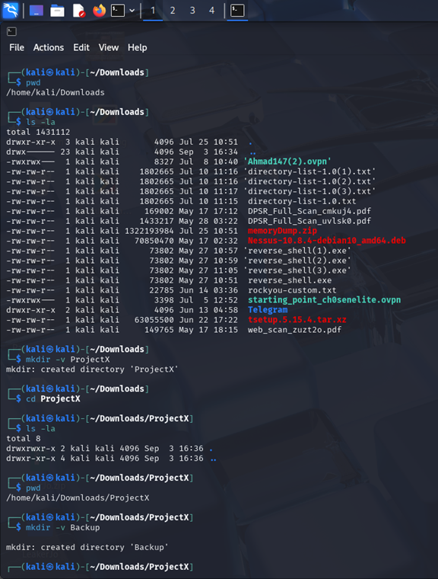
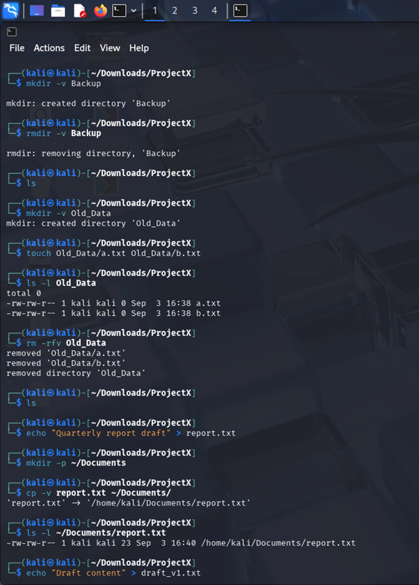
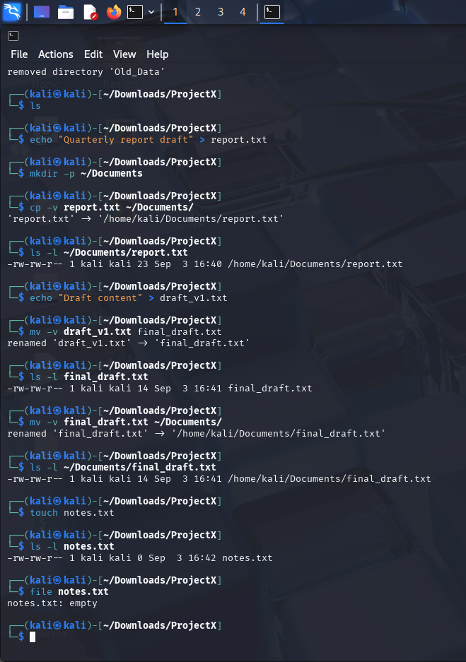

Task 6 – Windows Commands
Equivalent commands in Command Prompt for each step above.

A. List files and directories
Command: dir
Purpose: Displays all files and folders in the current directory.

B. Create a new directory named ProjectX
Command: mkdir ProjectX
Purpose: Creates a new folder called ProjectX.

C. Change directory into ProjectX and list contents
Command: cd ProjectX
Command: dir
Purpose: Changes the working directory to ProjectX and shows its contents.

D. Print the current working directory (full path)
Command: cd
Purpose: Shows the full path of the current directory.

E. Create a subdirectory named Backup
Command: mkdir Backup
Purpose: Creates a subfolder Backup inside ProjectX.

F. Remove the empty directory Backup
Command: rmdir Backup
Purpose: Deletes the Backup folder (only if it is empty).

G. Create a non-empty folder Old_Data, add files, then delete it
Command: mkdir Old_Data
Command: echo test1 > Old_Data\a.txt
Command: echo test2 > Old_Data\b.txt
Command: dir Old_Data
Command: rmdir /s /q Old_Data
Command: dir
Purpose: Demonstrates creating a folder with files, then removing it completely.

H. Create a file report.txt, make a Documents folder, copy the file there, verify
Command: echo Quarterly report draft > report.txt
Command: mkdir Documents
Command: copy report.txt Documents\
Command: dir Documents
Purpose: Creates a text file, copies it to a Documents folder, and verifies the copy.

I. Create draft_v1.txt, rename to final_draft.txt, verify, then move to Documents
Command: echo Draft content > draft_v1.txt
Command: ren draft_v1.txt final_draft.txt
Command: dir final_draft.txt
Command: move final_draft.txt Documents\
Command: dir Documents
Purpose: Renames a file and then moves it to another folder.

J. Create an empty file notes.txt and verify
Command: type nul > notes.txt
Command: dir notes.txt
Purpose: Creates an empty file and shows its details.

Screenshots:
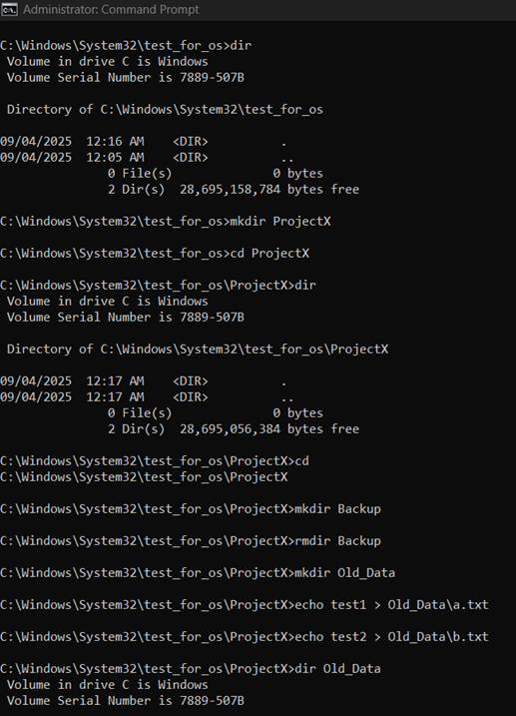
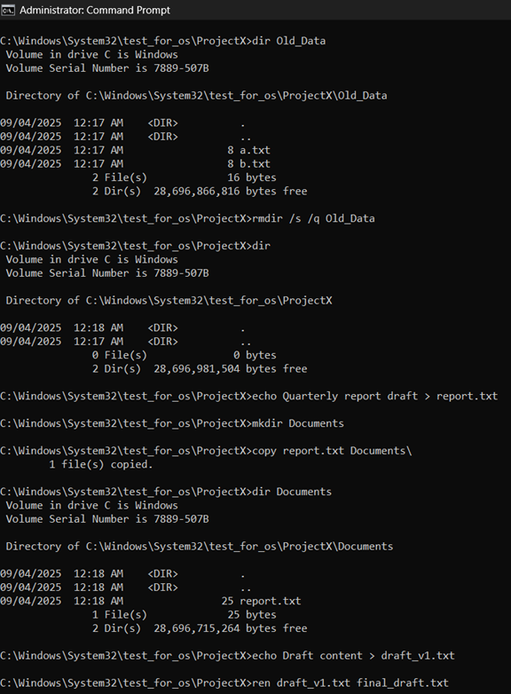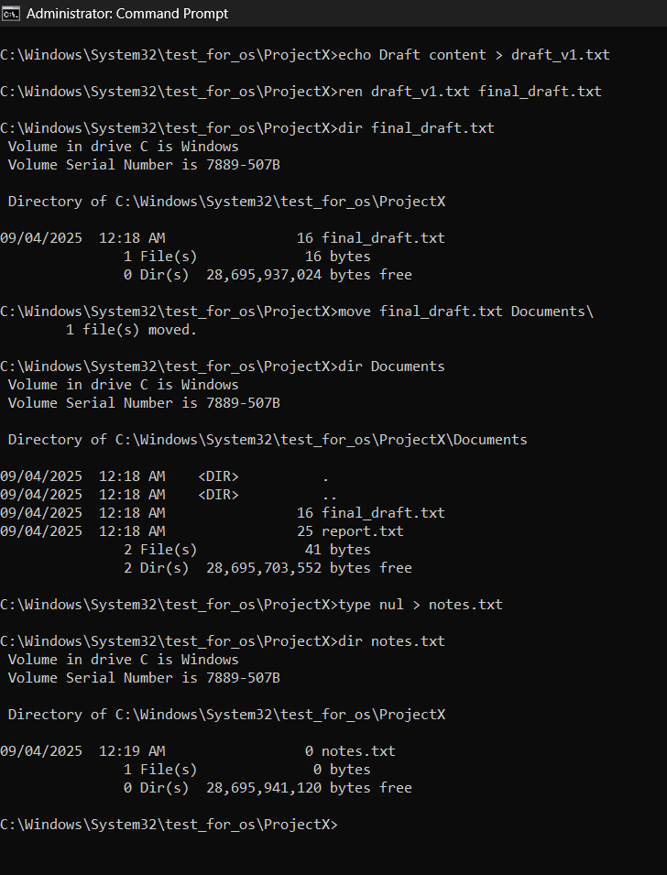

Task 7 – Artificial Intelligence in Operating Systems

A. How has the integration of AI transformed the development of modern operating systems?
The integration of Artificial Intelligence (AI) into operating systems marks a profound shift from static, rule-based platforms to dynamically adaptive systems. By embedding AI capabilities—such as machine learning and predictive analytics—OSs are now able to anticipate user behavior, optimize resource allocation, and self-adjust in response to usage patterns. AI-enhanced OSs can pre-load frequently used applications, intelligently manage memory, and tailor settings to individual preferences, significantly improving performance and user experience. (WebAsha)

B. What are the key AI technologies being incorporated into operating systems today?
Current AI-integrated technologies in modern OSs include:
- Machine Learning (ML) and Predictive Analytics: Used for optimizing system processes, pre-fetching data, and tuning performance based on user habits. (WebAsha, arXiv)
- Natural Language Processing (NLP) and Large Language Models (LLMs): Enable enriched human-computer interaction, such as handling natural-language commands, predicting user intent, and even serving as conversational interfaces. (Wikipedia)
- Natural User Interfaces (NUIs): Voice, gestures, and context-aware input modes are increasingly replacing traditional GUIs, offering more intuitive and seamless interaction. (Walturn)

C. What role will AI-powered voice and natural language interfaces play in replacing traditional OS interaction methods?
AI-powered voice and natural language interfaces are poised to transform how users interact with operating systems by enabling context-aware, conversation-driven experiences. These natural interfaces remove the reliance on keyboards, mice, and pointing devices by processing human speech and gesture input directly. Systems like virtual assistants (e.g., Siri, Cortana) exemplify this shift, allowing users to perform tasks via voice commands across devices. (Wikipedia)
Looking forward, OSs are increasingly becoming ambient and multi-modal—capable of understanding on-screen context and user intent to carry out commands intelligently. Developments like Windows 12 preview an OS that responds to intent through both voice and visual context, executing tasks as a digital agent while blending local and cloud AI. (Windows Central)

References
- Webasha. (Mar 22, 2025). AI integration in operating systems. (WebAsha)
- AIAcquisition. (2024). What is an Artificial Intelligence Operating System. (AI Acquisition)
- Walturn. (Jan 26, 2025). Traditional OS to AI OS: The Evolution of Operating Systems. (Walturn)
- Zhang et al. (2024). Integrating AI into Operating Systems: A Comprehensive Survey. (arXiv)
- Ge et al. (2023). LLM as OS, Agents as Apps. (arXiv)
- Wikipedia. Siri. (Wikipedia)
- Wikipedia. Virtual assistant. (Wikipedia)
- Windows Central. (2025). 'Windows 12' will understand your intent. (Windows Central)
- ITPro. (2025). Future Windows will offer 'multimodal' experiences. (itpro.com)

Task 8 – Secure Collaborative Environment for CityTechnologies Project
The following steps demonstrate how to configure users, groups, directories, and permissions on a Linux system to establish a secure collaborative environment for the CityTechnologies project. All privileged actions are performed using the administrator account (e.g., kali) with sudo.

A. User Account Creation (Khaled and Amal)
Command: sudo adduser khaled
Command: sudo adduser amal
Purpose: Creates two user accounts, Khaled and Amal. During creation, strong passwords should be enforced.

B. Project Directory Setup
Command: sudo mkdir /home/CityTechnologies
Command: sudo touch /home/CityTechnologies/Takamul_iot
Command: sudo touch /home/CityTechnologies/izam_iot
Command: sudo touch /home/CityTechnologies/Shabakat_iot
Purpose: Creates the project directory with the required three files.

C. Manager Account Setup (ahmed_manager)
Command: sudo adduser ahmed_manager
Purpose: Creates a project manager account with secure password settings.

D. Engineers Group Configuration
Command: sudo groupadd Engineers
Command: sudo usermod -aG Engineers khaled
Command: sudo usermod -aG Engineers amal
Purpose: Creates a group called Engineers and adds Khaled and Amal as members.

E. Project Manager Assignment (Owner of Project Directory)
Command: sudo chown -R ahmed_manager /home/CityTechnologies
Purpose: Assigns ahmed_manager as the owner of the CityTechnologies directory and its files.

F. Group Ownership Assignment
Command: sudo chgrp -R Engineers /home/CityTechnologies
Purpose: Sets group ownership of the directory and all its files to Engineers.

G. Manager Access Rights (Full Access)
Command: sudo chmod -R u+rwx /home/CityTechnologies
Purpose: Grants the owner (ahmed_manager) full rights (read, write, execute).

H. Engineers Access Rights (Read, Write, Execute)
Command: sudo chmod -R g+rwx /home/CityTechnologies
Purpose: Grants the Engineers group read, write, and execute permissions for all files.

I. Restrict Other Users
Command: sudo chmod -R o-rwx /home/CityTechnologies
Purpose: Removes access for all other users, except execution where explicitly required.

J. Directory Permissions (Specific Setup)
Command: sudo chmod 750 /home/CityTechnologies
Purpose:
- Owner (ahmed_manager): Read & Write (and execute for directory access).
- Group (Engineers): Read-only (and execute for directory traversal).
- Others: No access.

K. Security Verification
Command: ls -ld /home/CityTechnologies
Command: ls -l /home/CityTechnologies
Purpose: Verifies permissions and ownership of the directory and files.

L. User Access Testing (as Khaled)
Command: su - khaled
Command: cd /home/CityTechnologies
Command: ls -l
Purpose: Confirms that Khaled can access files and test read/write/execute permissions.

M. Sensitive File Protection (AccessControlPlan.txt)
(Performed by admin account, not Khaled)
Command: sudo touch /home/CityTechnologies/AccessControlPlan.txt
Command: sudo chown ahmed_manager /home/CityTechnologies/AccessControlPlan.txt
Command: sudo chgrp Engineers /home/CityTechnologies/AccessControlPlan.txt
Command: sudo chmod 640 /home/CityTechnologies/AccessControlPlan.txt
Purpose:
- Owner (ahmed_manager): Read & Write.
- Engineers group: Read-only.
- Others: No access.

N. Controlled File Modifications
Command: sudo chmod +t /home/CityTechnologies
Purpose: Adds a sticky bit to the directory, preventing users from deleting files they do not own while still allowing them to create/edit their own.

O. Post-Project Cleanup
Command: sudo deluser khaled --remove-home
Command: sudo deluser amal --remove-home
Command: sudo deluser ahmed_manager --remove-home
Purpose: Removes the user accounts and their home directories after project completion.

Screenshots :
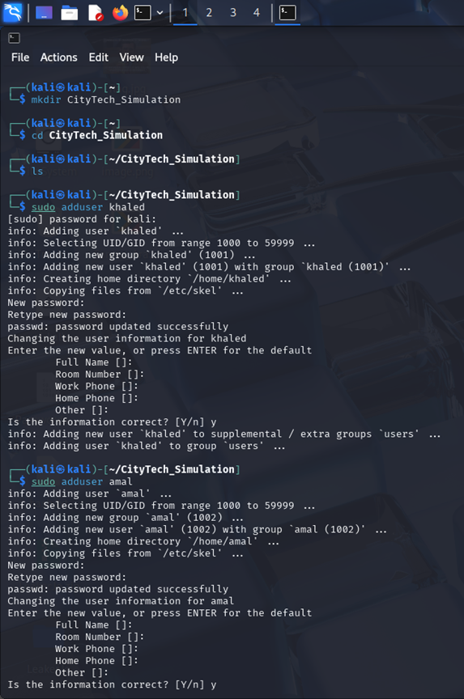
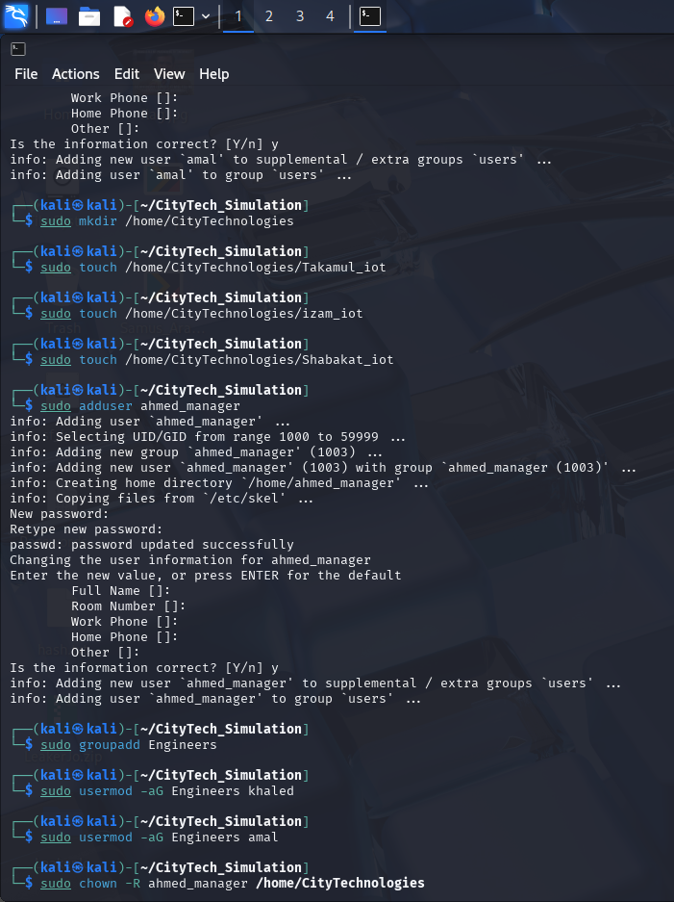
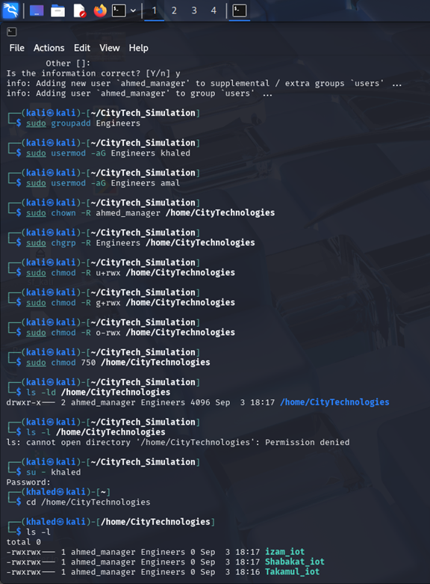
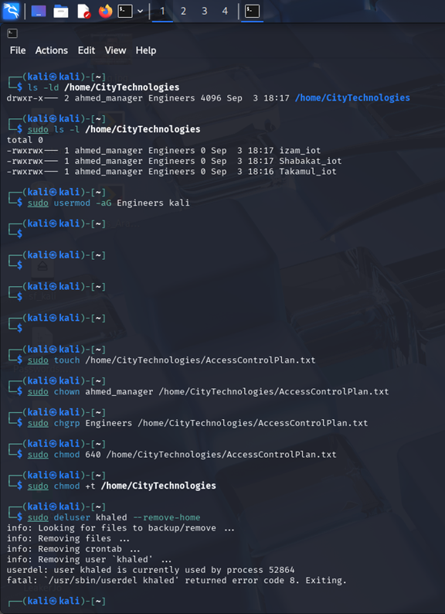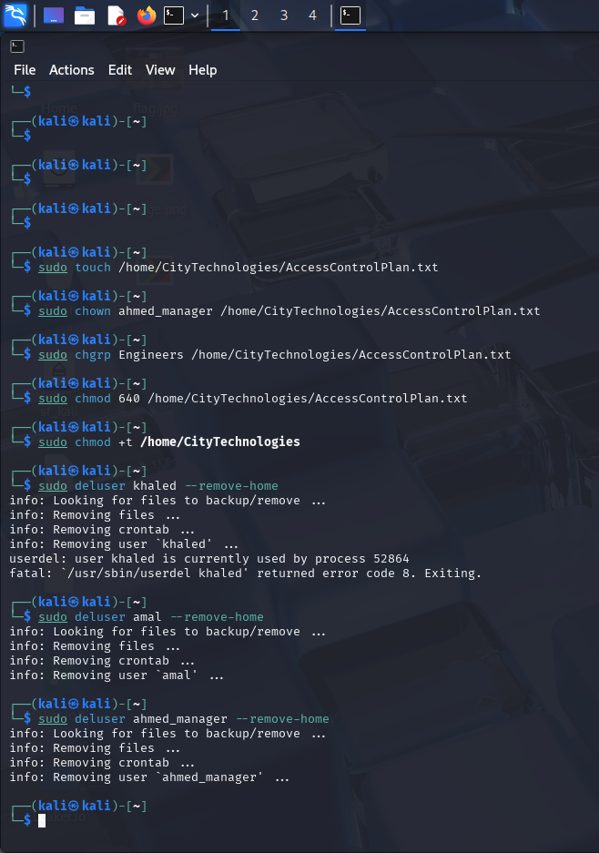

Task 9 – Virtualizaton and Containerizaton
A. What are virtualizaton and containerizaton
• Virtualizaton refer to techniqe of creatng virtual machines VMs each running its own full operatng system on top of hypervisor. This hypervisr manage system resorces providng strong isolatn between guest OSs and alowing diverse OS instnces on a single host
• Containerizaton or OS level virtualizaton uses lightweit containers to package applicatons and there dependncies al sharing the host OS kernel while maintaing process isolatn and enviroment consistncy
B. How do modern operating systms support virtualizaton
Modern OSs suport virtualizaton through several approches
• Hypervisors OSs often includ or support type 1 bare metal eg Xen Hyper V and type 2 hosted eg VirtualBox hypervisrs enablng secure and isolatd VMs
• Hardware Assistd Virtualizaton Many modern processors provde virtualizaton extensons like Intel VTx and AMD V enhancng performnce and reducn overhead of virtualizaton
• OS Level Virtualizaton Support
o Namespaces and cgroups on Linux power containers via LXC Docker etc offerng efficint resorce isolatn
o Other systms use mechanisims like Solaris Zones or FreeBSD Jails to achiev similar lightweit isolatn
C. Why adopt hybrid approach combinng virtualizaton and containerizaton
A hybrid model runng containers insid VMs bring togethr strength from both technlogies
• Enhancd Isolaton & Securty Containers benfit from isolatn between applicatons runing them in VMs adds second layer of defnse protectng host OS from potentil container level breach
• Improvd Compatibillty VMs ensure consistnt enviroments for containers avoidng compatibillty issue across diferent host OS configrations
• Better Resorce Managemnt Hardware resorces CPU memory IO can be finly control at VM level while containers alow dynamc allocatn within that VM enhancng utilizatn and flexibillty
This hybrid setup suport
• Scalabillty Rapid and efficint deploymnt of containerizd applicatns across multple VMs in cloud
• Securty Defens in depth compromisd container does not direct expose the host
• Portabillty Stackable deploymnt VM + container make transiton betwen cloud or on prem enviroments seemless

References
- Ge-eksfor-geeks. (2025). Virtualization vs. Containerization. GeeksforGeeks
- Red Hat. (2024). What is virtualization? Red Hat
- Trenton Systems. (2023). Virtualization vs. Containerization (hybrid approach benefits). trentonsystems.com
- Wikipedia. Hypervisor (overview of virtualization technologies). Wikipedia+1

Task 10 – Cybersecurity, Privacy, and Modern Operating Systems

A. Open-source vs. proprietary OSs for national cybersecurity: implications
- Open-source OSs (e.g., Linux variants) offer transparency and auditability (any party can review code), enable rapid community-driven patching, reduce vendor lock-in, and support national “digital sovereignty” via inspectable stacks. The main risks are supply-chain exposure (ubiquitous shared dependencies), uneven maintenance, and unclear accountability when a critical open-source component fails.
- Proprietary OSs (e.g., Windows, macOS) typically provide vendor accountability, integrated update channels, certified security features, and enterprise support; but their closed code limits external scrutiny, can concentrate risk in a single vendor, and may complicate national assurance and sovereignty goals.
- Policy takeaway: Nations should not frame this as “either/or.” They should recognize OSS as critical infrastructure (invest in securing it) while also holding proprietary vendors to secure-by-design standards, contractual SLAs, and transparency (e.g., SBOMs). CISA
B. Best approach for a national cybersecurity strategy (based on A)
A hybrid, risk-based approach is most effective:
- Strengthen the open-source ecosystem (funding, maintainers, vulnerability response, SBOM adoption) because governments and vendors both depend on it.
- Impose secure-by-design obligations on commercial software (memory-safe languages where feasible, default hardening, rapid patch pipelines) and require transparency (attestations, SBOMs).
- Adopt Zero Trust and modern assurance (continuous monitoring, identity-centric access) across public networks and devices.
- Institutionalize public–private coordination to respond to systemic vulnerabilities.
This aligns with the U.S. National Cybersecurity Strategy (2023), which prioritizes securing the open-source ecosystem, SBOMs, and shifting security burdens onto capable actors. The White House
C. AI-driven threat detection in modern operating systems
Modern OS security stacks embed machine learning and cloud-assisted analytics to detect novel malware and anomalous behavior beyond signatures. For example, Microsoft Defender “next-generation protection” in Windows combines local and cloud ML models, behavior analysis, and heuristics to block suspicious processes and files in real time—an approach representative of OS-level endpoint protection today (with analogous EDR capabilities on macOS and Linux via cross-platform agents). Microsoft Learn
References :
A) CISA. Open Source Software Security Roadmap (2023). CISA
B) The White House. National Cybersecurity Strategy (2023). The White House
C) Microsoft Learn. Next-generation protection overview (Defender). Microsoft Learn

